April James

[jamesap@oregonstate.edu](mailto:jamesap@oregonstate.edu)

**Project #6: Catmull-Rom Jellyfish**

The sixth CS450 graphics assignment is all about Geometric Modeling. The objectives included:

* Learning about geometric modeling styles in OpenGL
* Learning about curve sculpting techniques using Bezier curves and Catmull-Rom Curves
* Utilizing the Catmull-Rom Spline equation to model curves in OpenGL
* Animate sculpted curves

For this project, I created a singular CR curve by reading from a 2D array into an array of Point structs. To animate the curve, I ran the points through a function that translated the coordinates based on a factor of Time, then graphed the altered locations. The curve was duplicated and redrawn multiple times to create a 3D object using the glRotatef() function, and the color gradient was created by adjusting the RGB values based on changing X and Y coordinate positions and a factor of time.

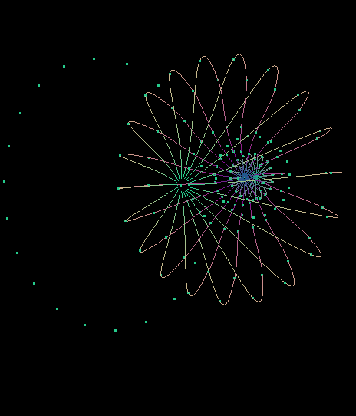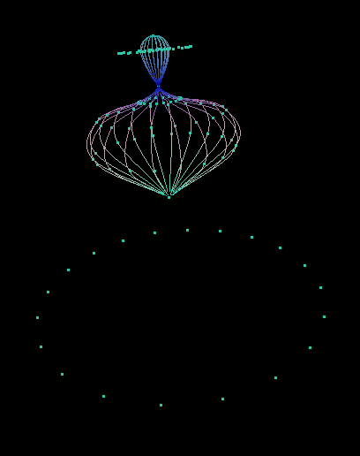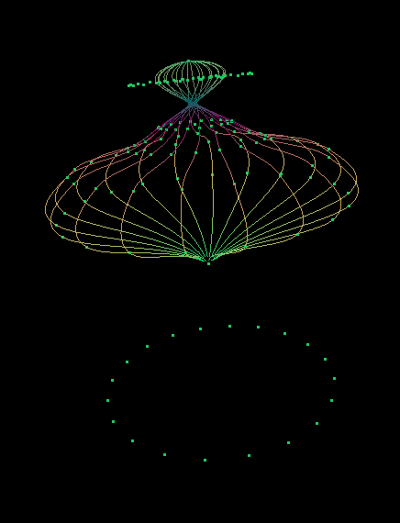

Figure 1: Curves in Action!

Figure 3: A cool angle!

Figure 2: Frozen State

Here is a link to the project video: <https://youtu.be/BoQAkYR45EQ>

Thank you!